SCH4C October 2017
Diluting Standard Solutions
Requires more specialized glassware and a little math!
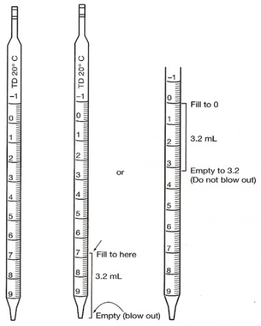 | 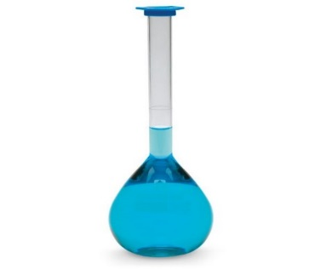

Suppose a solution is TOO concentrated for our purposes:
For example:
When the school buys hydrochloric acid, it comes in a VERY concentrated form: 12 mol/L
This concentration is
- Way too dangerous for students to work with
- Unnecessary for labs that we perform.
We typically use concentrations of 1 mol/L or less.
There are two methods used to dilute a solution:
Method #1
We can add water to the whole thing  This is the method used when diluting a can of frozen orange juice. You buy it concentrated so that it takes up little room to store. The instructions on the can tell you how to dilute it to make it the right concentration.  This is the method is NOT appropriate for diluting the hydrochloric acid. | 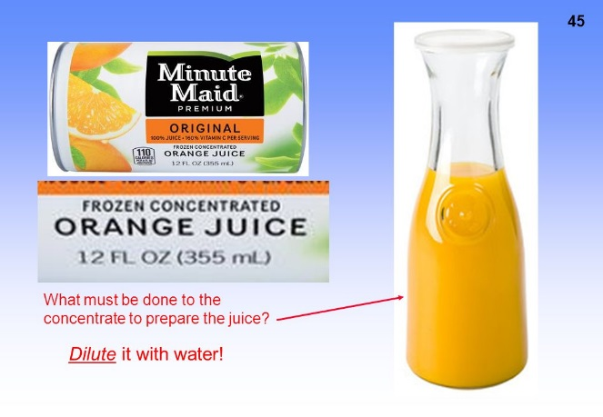
Why? You will have diluted the whole thing and
- This might not be the concentration you need the next time
- We would have serious storage problems! – Where to put it all?

Method #2:
We can remove a pre-determined amount and dilute this with water to make just the amount we need for the lab.  Kind of like removing a little bit of bleach from the container and adding it to a bucket of water.  Today, we are going to learn how to use method #2. | 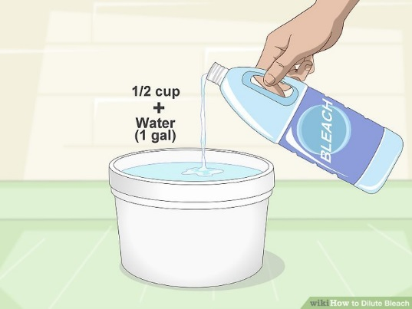

To do so, we need the formula: C₁ x V₁ = C₂ x V₂
Suppose 100 mL is needed for the whole class and the required concentration is 0.50 mol/L. We will start with the concentrated form of the acid: 12 mol/L
The concentrated acid: | The dilute acid:
C₁ = 12 mol/L  V₁= ??? (this is how much we are going to take out of the bottle and dilute) | C₂ = 0.50 mol/L  V₂= 100 mL (the desired volume)
C₁ x V₁ = C₂ x V₂
NOTE: Changing mL to L is unnecessary with this formula.
12 x V₁ = 0.50 x 100

Now for the glassware!
- Using a 5 mL pipette, you would remove exactly 4.17 mL of the acid from the 12 mol/L bottle
- You would place this into an empty 100 mL volumetric flask and then add water to the fill line.
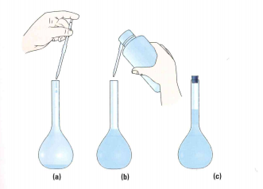
NOTE: When using glass pipettes and volumetric flasks:
A little concave dip in the water will form – it’s called a meniscus. Always measure from the BOTTOM of the meniscus!
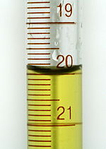

TRY THESE:
- What volume ( ) of a 1.5 mol/L ( ) solution of HCl would you need to make 500 mL ( ) of 0.50 mol/L HCl?
Concentrated solution | Dilute solution
C₁ =  V₁ = | C₂ =  V₂ =
C₁V₁ = C₂V₂

- What volume of 2.0 mol/L NaCl is needed to make 50.0 mL of 0.20 mol/L
Concentrated solution | Dilute solution
C₁ =  V₁ = | C₂ =  V₂ =
C₁V₁ = C₂V₂

- 25.0 mL of 1.5 mol/L NaOH is placed in a 100 mL volumetric flask and water is added to the fill line. What is the new concentration of the acid?
Concentrated solution | Dilute solution
C₁ =  V₁ = | C₂ =  V₂ =
C₁V₁ = C₂V₂

- 10.0 mL of 0.50 mol/L NaOH is placed in an empty 250 mL volumetric flask. Water is added to the fill line. What is the new concentration of the NaOH?
Concentrated solution | Dilute solution
C₁ =  V₁ = | C₂ =  V₂ =
C₁V₁ = C₂V₂

- 5.0 mL of 7.0 mol/L solution of NaCl is added to an empty 100 mL volumetric flask and water in added until it reaches the fill line. What is the new concentration of the NaCl?
Concentrated solution | Dilute solution
C₁ =  V₁ = | C₂ =  V₂ =
C₁V₁ = C₂V₂

